Dewar Dryer Project.

HHMI/JFRC
Igor Negrashov
13 July 2012
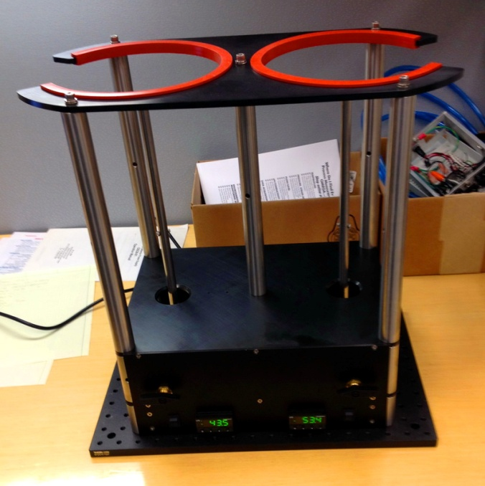

Dewar dryer is designed to warm and dry two 4-liter cryogenic Dewar flasks that are used for preparation of flash-frozen samples. The compressed air from lab supply line blows through a stainless steel pipe with cartridge heater into each Dewar flask. Air flow could be opened or closed for each flask using valve on front panel. Temperature of heater is monitored using J type thermocouple and controlled by 1/32 DIN format temperature controller. Each controller is programmed to use a “soak” mode – after power up it rises temperature slowly to preset value and keeps it stable for 30 min; after that controller shut heater down. The process can be reset by turning power off and on again. The safety switch turns heater off in case no Dewar flask is in drayer.

